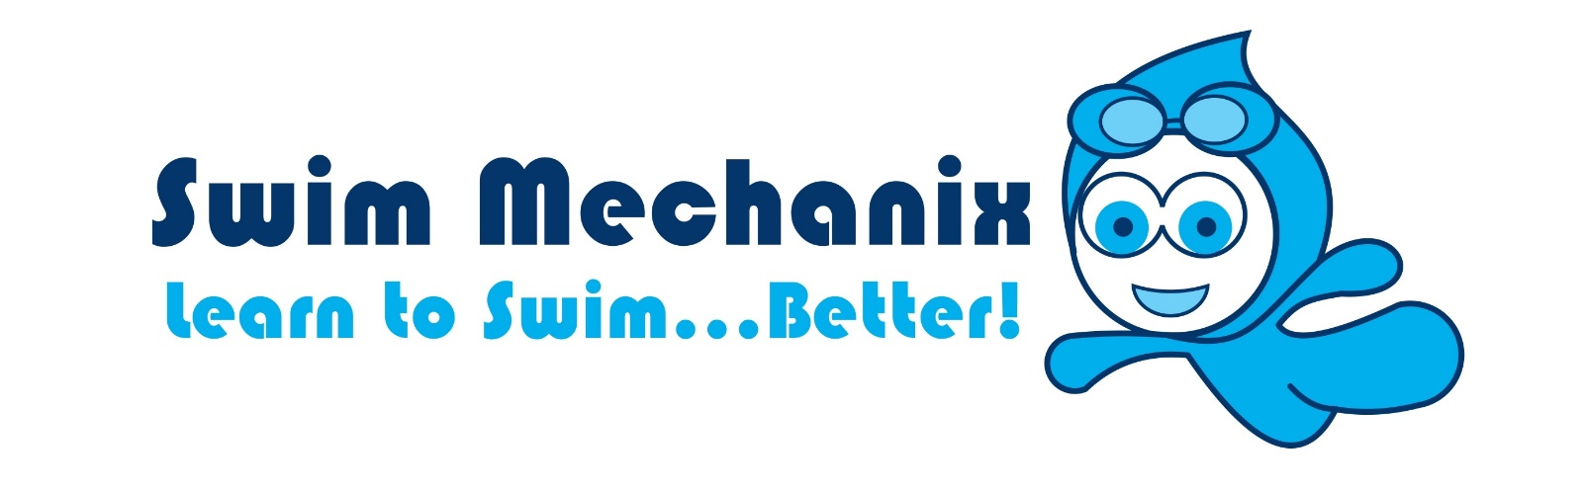
Welcome!
As a new client at Swim Mechanix we’d like to give you a run down on our program and the requirements of your lessons.
Facility
Our hydro pool is heated to 34 degrees and is located on the grounds at Success Primary School, 390 Wentworth Parade. Parking is available in the main administration carpark and signage to the external door is nearby. Change room facilities are within the building and as a matter of safety we ask that you stay within the pool area & change rooms when visiting the facility.
NO FOOD is allowed to be consumed within the facility. If you must feed your child solids, please do so outside the external doors near the carpark.
Do not leave nappies at the centre. Although there are bins, these are not always emptied regularly by the school.
Our lease depends largely on how our clients and staff treat the space. Please treat it as your own home pool and report any incidents of damage, uncleanliness or accidents.
What to bring
Babies & toddlers not yet toilet trained are legally required to wear disposable or reusable swimming nappies when in the pool. It is a requirement of the facility that bathers are also worn over the top to prevent any leakages that may result in cancellation of classes, infections or extreme pool maintenance as the pool is used daily by special needs students at the school.
Every swimmer will be issued with a swim cap that needs to be worn for each lesson to help keep our pool clean. These are free with your initial enrolment, but please pop your child’s name on them as you will need to purchase a new cap for $5.50 if they get lost.
Swim Mechanix recommends that parents wear comfortable bathers as well as a shirt over the top so that baby can learn to grasp and climb up during our lessons.
Our Program
Swim Mechanix is a Royal Life Saving Society endorsed Swim School offering Infant & Preschool Aquatics and Swim & Survive Programming Levels 1 through to 5.
Our Infant & Toddler programming focusses primarily on a parent’s understanding of water safety and water familiarity for infants & toddlers. During the half hour lessons we encourage babies & toddlers to become comfortable in the water developing both skills essential for independent swimming as well as safety.
Lessons are taught in progressions depending on the age of the child with cognitive and physical developmental stages in mind. Children from 3 months of age will be in the same “level” for an average of 6 months. More information on our levels is available at the Royal Life Saving WA website www.lifesavingwa.com.au
Children are often transitioned to Independent Swimming Classes between the age of 3.5 and 4 years, but this depends on the individual child, rather than the expectation. We prefer to keep parents in with the children until they show signs of being emotionally ready and physically strong enough to continue lessons without the extra support.
From level 1 onwards children are encouraged to move through the Swim & Survive program developing partial and whole skills. At first many are safety oriented, but by level 3 actual stroke development is high on our programming agenda. Lessons are developed to be well rounded, that is, to teach lots of small skills to build a strong and confident swimmer, not just what you see on the certificate.
Certificates will be given to all participants once they complete the level of attainment.
Staff
All of our talented Instructors are fully qualified and often specialise in particular aquatics instruction such as Infant & Preschool or Adults.
Liz Fowler is qualified in Infant Aquatics (specialised), Teacher of Swimming & Water Safety, Towards Competitive Strokes, Adults Instructor & Bronze Licence Coach (Austswim & Swim Australia) with current Working with Children Check, Bronze Medallion & Senior First Aid. Liz also delivers Aquatic Training and programs such as CALD (Women Only Learn to Swim) & Specialised Intensive English School swimming for Royal Life Saving Society WA and is an Austswim Instructor Assessor.
Bronwyn Clark is a qualified Infant & Preschool Aquatics Instructor & Teacher of Swimming & Water Safety (Austswim) with current Working with Children Check and CPR.
Alexandra Preston is a qualified Infant & Preschool Aquatics Instructor & Teacher of Swimming & Water Safety (Austswim) with current Working with Children Check and CPR.
Ben Davidson, Sophie Preston, Lisa Vener and Alisha Morgan are all qualified Teachers of Swimming & Water Safety (Austswim) with current Working with Children Checks and CPR.
Contact
I am your everyday person for more information, feedback or concerns so please don’t hesitate to email me at liz@swimmechanix.com.au, or messaging me on the Swim Mechanix Facebook page https://www.facebook.com/SwimMechanix/ . I do my best to keep the Swim School running at its optimum and appreciate people’s input.
If you have anything you wish to know, email me. I look forward to meeting you all!

Kind regards
Liz Fowler
Swim Mechanix
www.swimmechanix.com.au

